**2024.07.24**

**Engineering Question of PN:02_PTP_USB_TO_RJ45_DRC**

**Question 1:**  The PCB board fabrication information is not specified.

**Suggestion:** Follow below information to make this board, unless otherwise specified.

Material: FR-4 TG≥130.

Finished board thickness shall be 1.6mm+/-10%.

Finished copper thickness shall be 35um on both outer layers and 18um base copper in inner layers

Gloss black color of solder mask.

White color of silkscreen

Surface finish shall be ENIG(1u”).

**Reply: I agree with this option**

**Question 2:** See below IMG, customer designed fingers pads on marked areas, but we find there is no any electric net for those fingers, they are are isolated, please confirm is normal?

**Suggestion:** Just follow the original gerber files.

**Reply: It's all right. That's how it should be. It's just a design decision.**

**PIC2:**

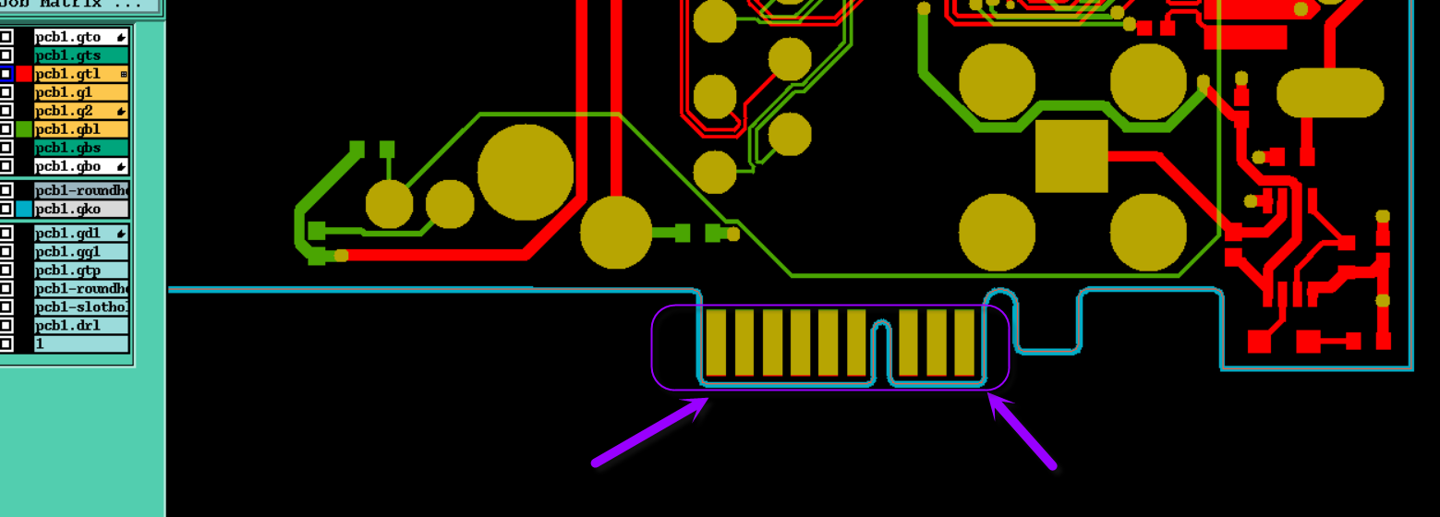

**Question 3:** See below IMG, for those fingers pads, if we need plated hard gold and chamfer?

**Suggestion 1:** No need plated hard gold and no chamfer.

**Suggestion 2:** Need plated hard gold, the hard gold thickness as 10u” to control, and need chamfer, the chamfer data as our company normally control.

**Suggestion 3:** No need plated hard gold, but need chamfer, the chamfer data as our company normally control.

**Reply: Suggestion 1**

**PIC3:**



**Question 4:** See below IMG, no find the marked Cu traces in gerber, please confirm

**Suggestion:** Ignore it

**Reply: Ignore it**

**PIC4:**

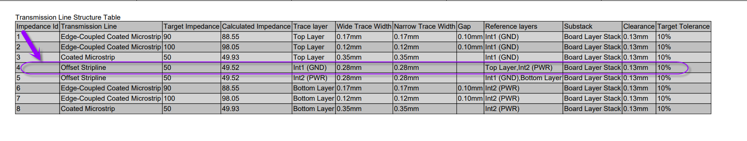

**Question 5:** See below IMG, the space of non-plated holes very closed to the Cu traces, it will be shaved cu traces in drill process

**Suggestion:** Allow to move the cu traces to avoid.

**Reply:** Allow to move the cu traces to avoid

**PIC5:**

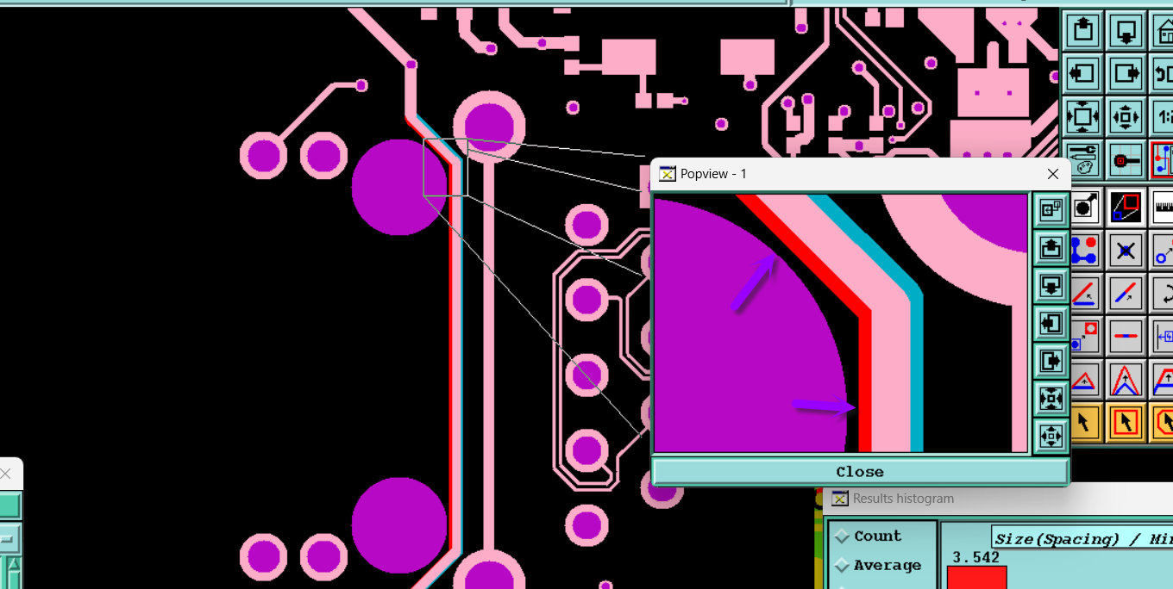

**Question 6:** See below IMG for example, the space of two holes just 5.9mil, it too small to insert soldmask dams between Cu pads.

**Suggestion:** Allow to shave the Cu pads to get 8mil to insert soldmask dams.

**Reply: Yes, you can cut off the Cu gaskets,**

**PIC6:**

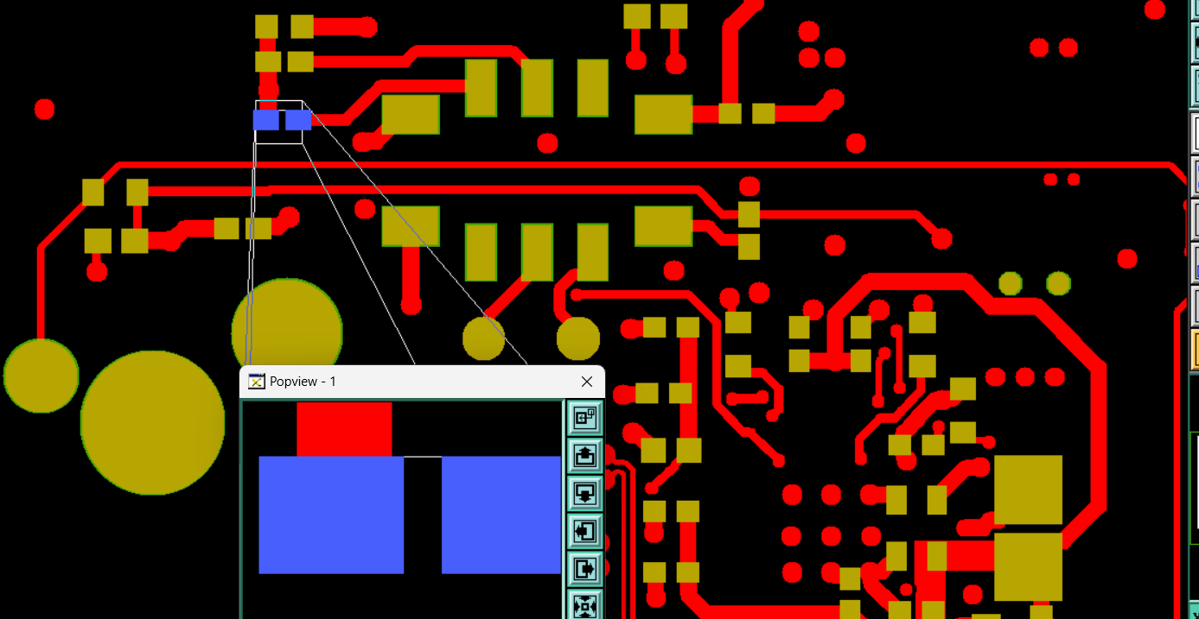

**Question 7:** See below IMG,the area of gold fingers have solder mask bridges，the design will cause the solder mask ink falled and maybe affect the function.

**Suggestion 1:** Delete the solder mask bridges between finger areas

**Suggestion 2:** Follow gerber, keep the solder mask bridge between fingers.

**Reply: Suggestion 2, this will not affect the operation of the product.**

**PIC7:**

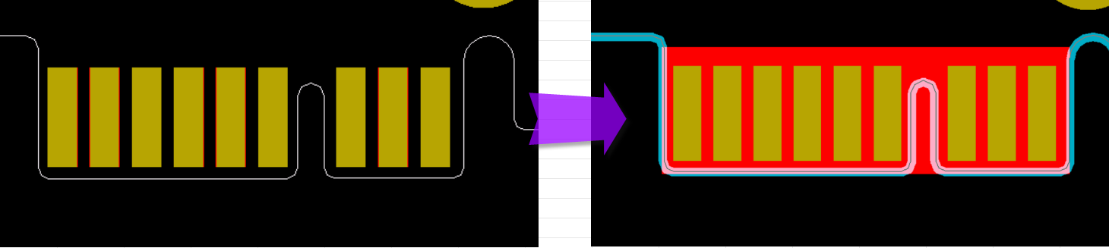

**Question 8:** See below IMG, to traceability, we will add datecode (wwyy) and silkscreen block(To laser engraving label (Include serial number info after assembly)) the top silkscreen layer, please confirm

**Suggestion:** Please confirm

**Reply: I agree with the proposal**

**PIC8:**

